**SMART STAR EXAMINATIONS BOARD**

**END OF TERM ONE EXAMINATION - 2024**

**READING**

**MIDDLE CLASS**

My name is…………………………………………..

1. **Match the pictures to sounds.**

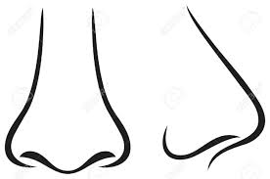**s**

 **t**

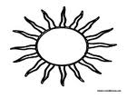

**i**

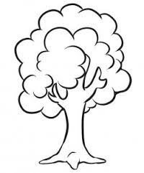

**p**

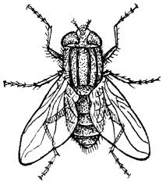

**n**

1. **Copy again.**

**e**

**r**

**s**

**ck**

**ck**

1. **Circle only sounds.**

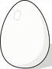

**e**

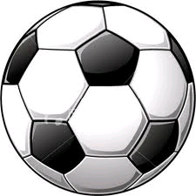

**d**

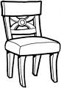

**a**

**s**

**n**

**t**

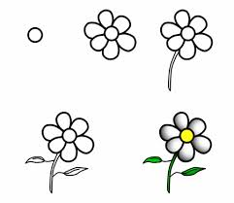

**m**

1. **Write the sound for the picture.**

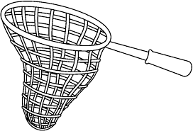

**n**



**______**

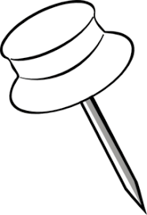

**______**

**_____**



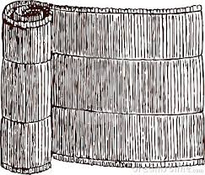 **_____**

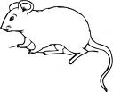 **____**

1. **Oral.**

**Sound and read.**

**at am**

**END**